touch mybash.sh- this command is used to create file in bash shell.

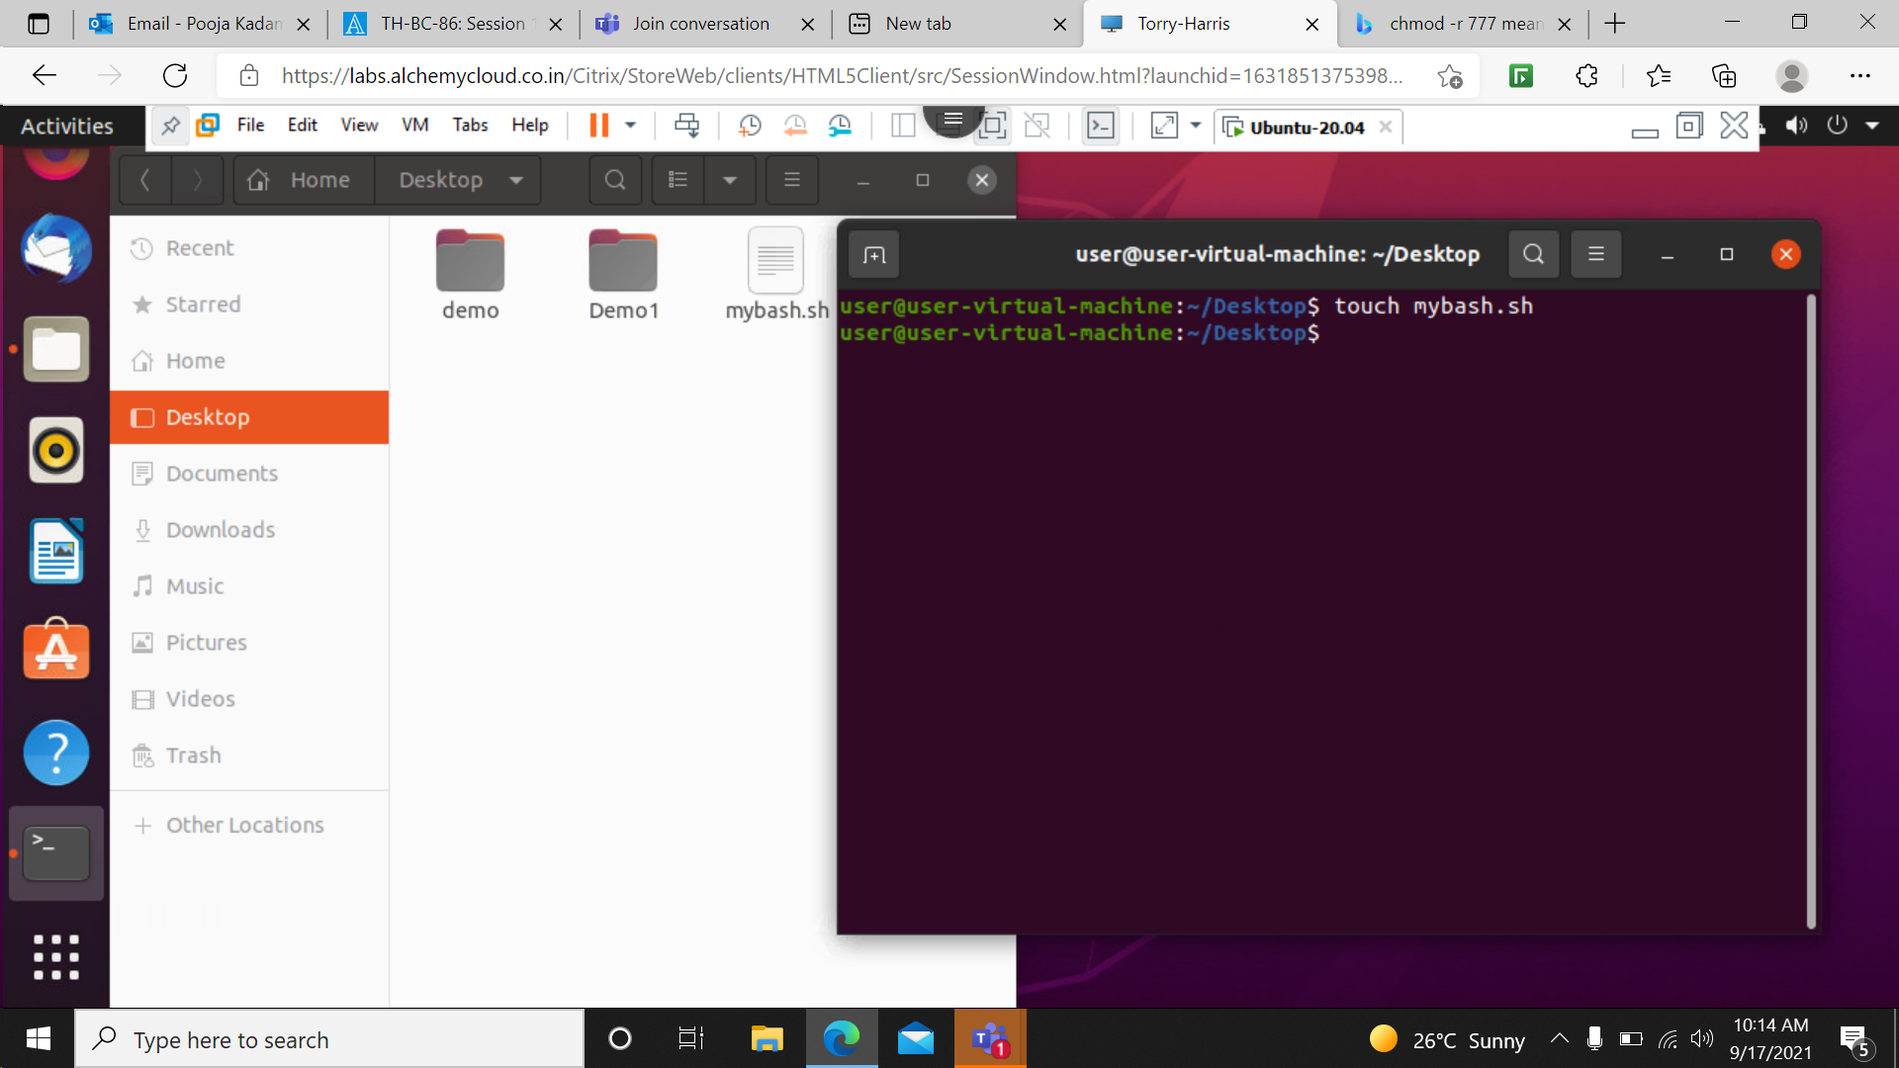

vim mybash.sh- This command is used to insert text inside a file named as mybash.

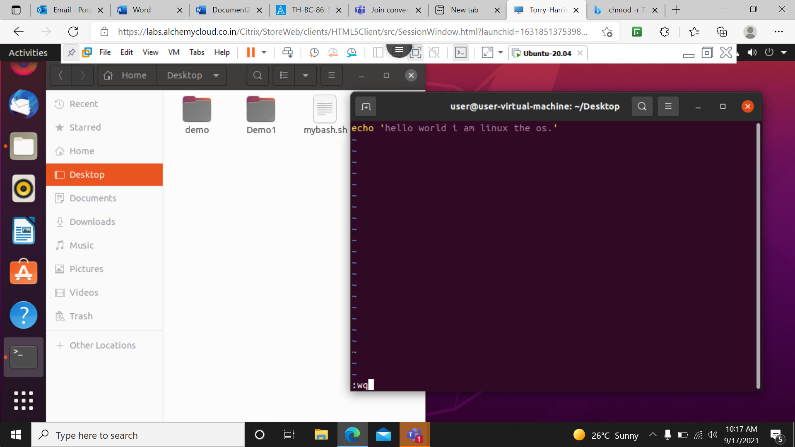

./mybash.sh- This command is used to execute the file.

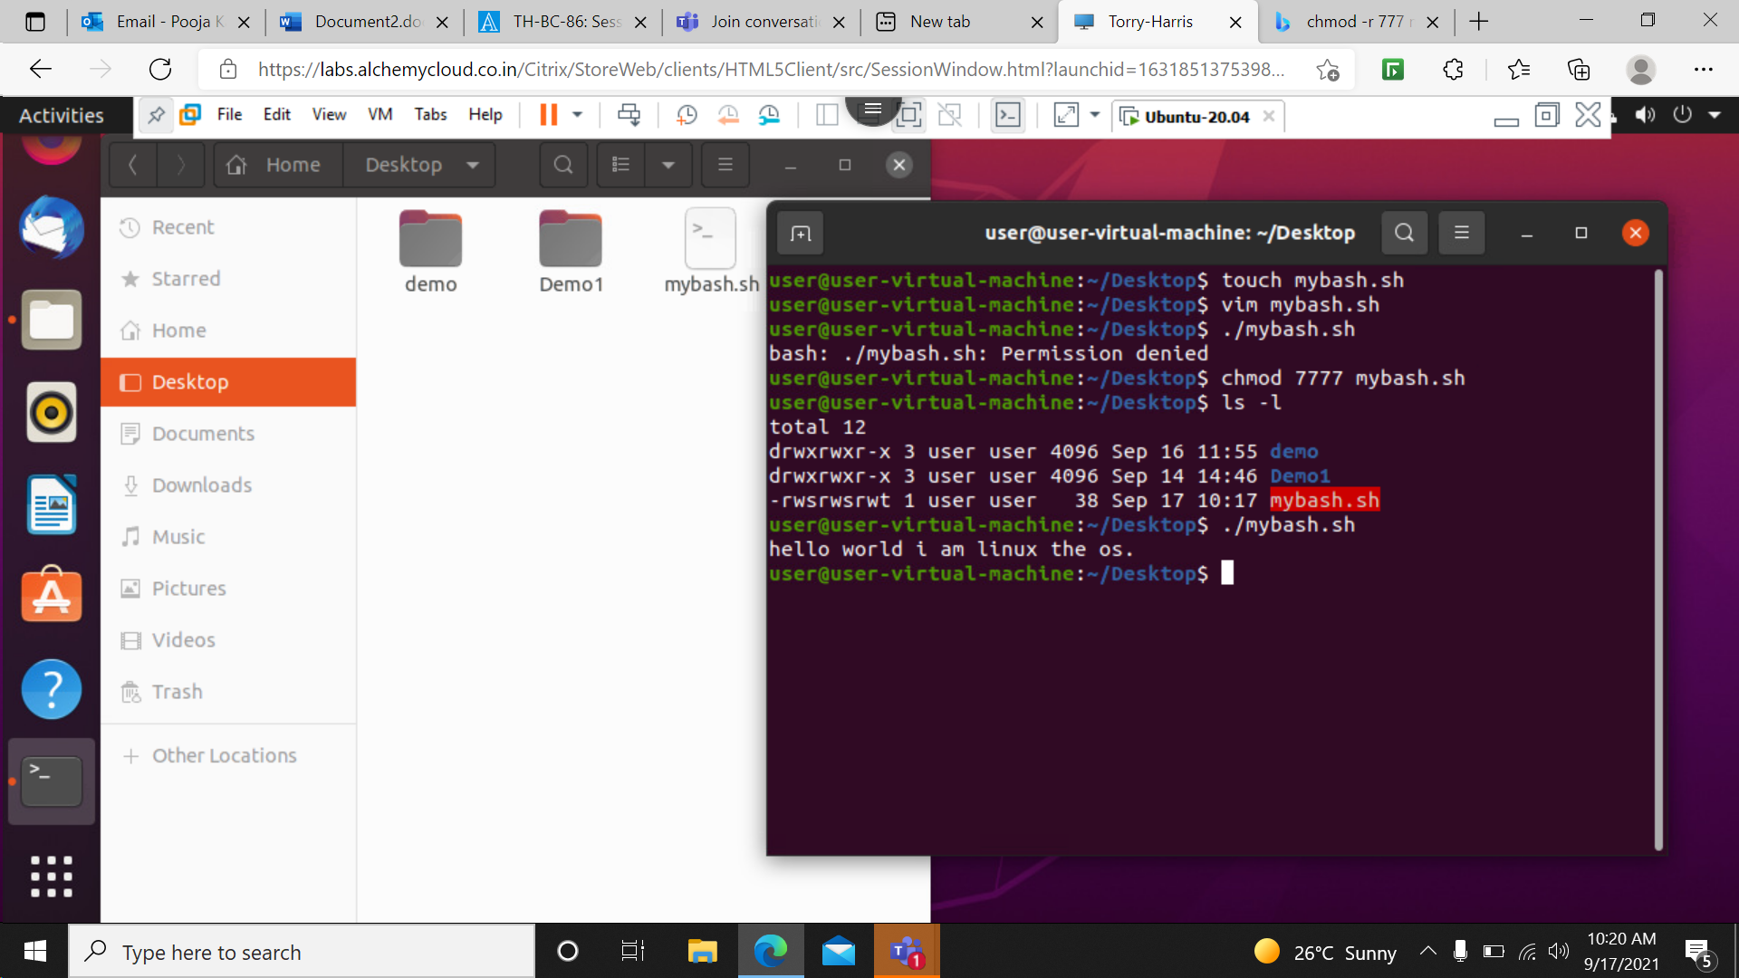

Chmod 777 mybash.sh- this command is used to give all permission to owner,user and all.



gedit data.sh- This command is use to open a file if the is already present in the location if file not then it will create a new file.

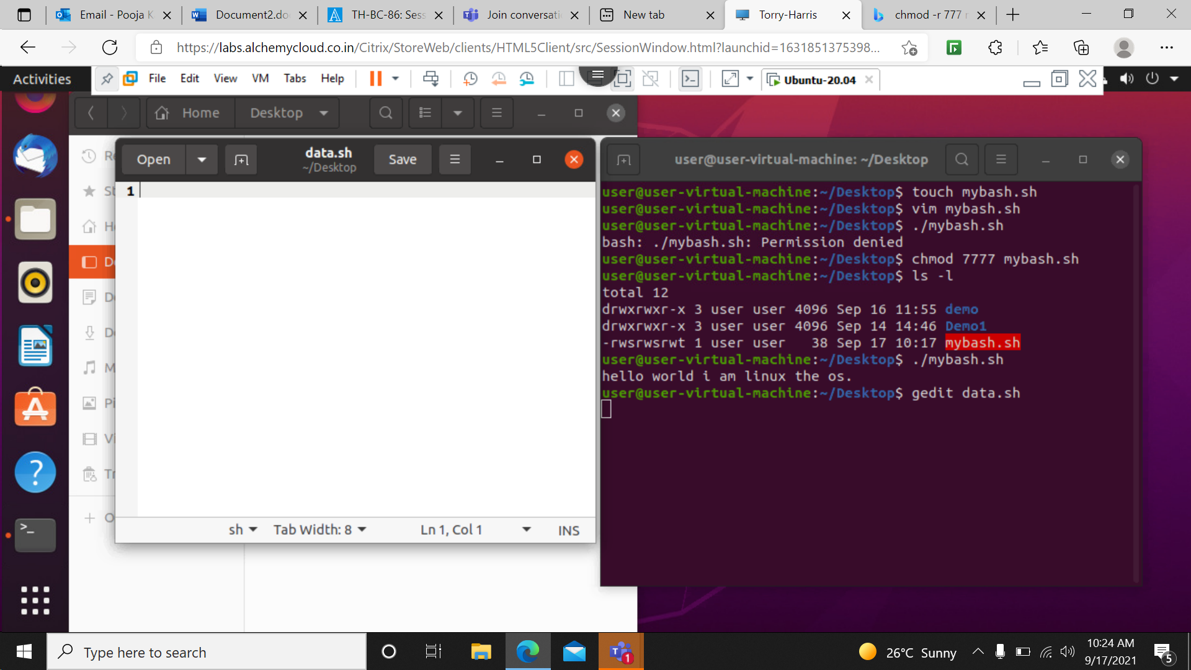

chmod 000 data.sh- This command is used to withdraw all rights from owner ,user and all.

The fille gets lock.

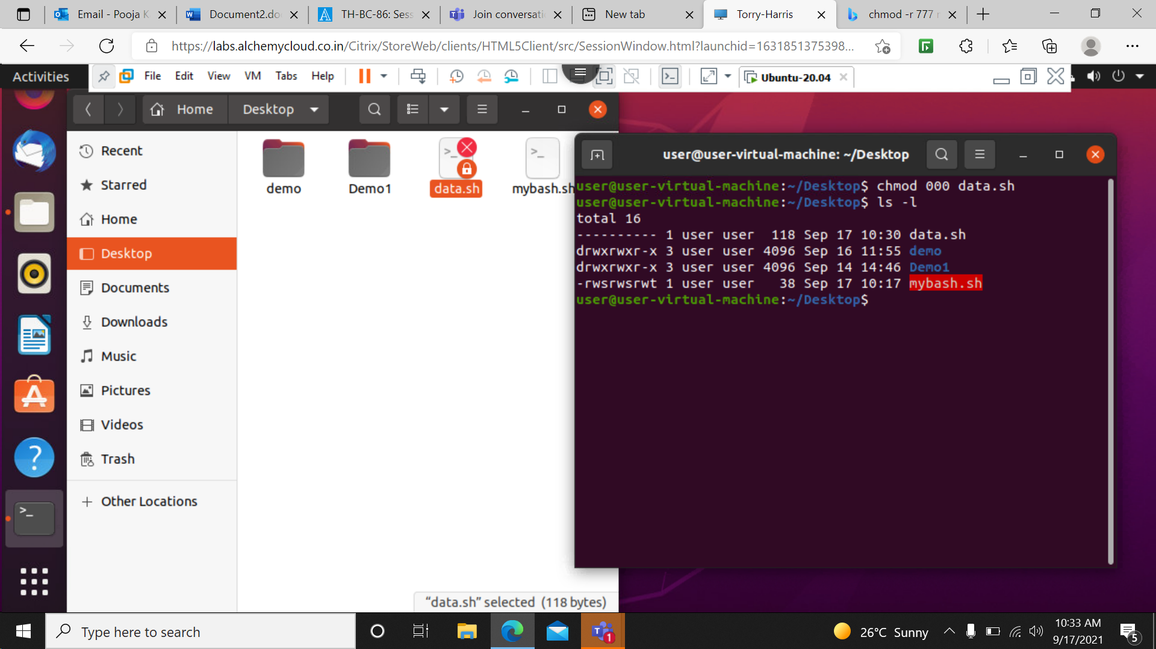

Chmod u+rx data.sh- This command is used to give read and execute permission to the user.



./data.sh- This command is to execute file inside that file we are giving command to create folders after execution new folders will be created .

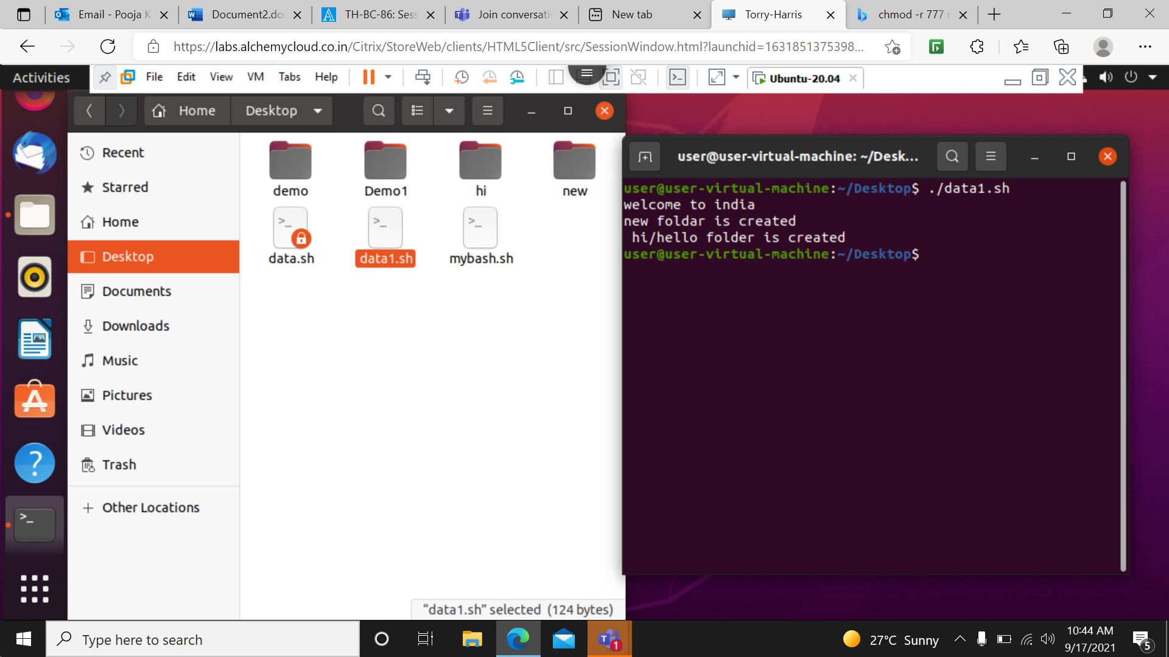

Rm –rf new – this command is used o delete the created folder.

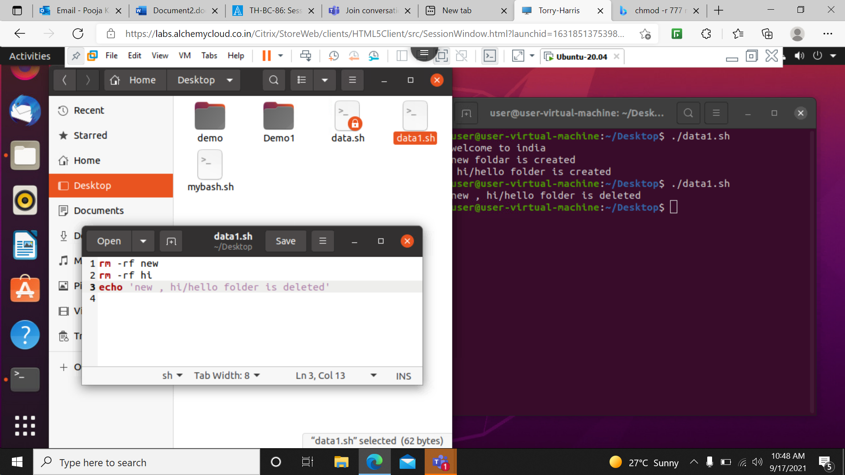

Echo ‘text here’ >> append – This command is used to append a text in a file.

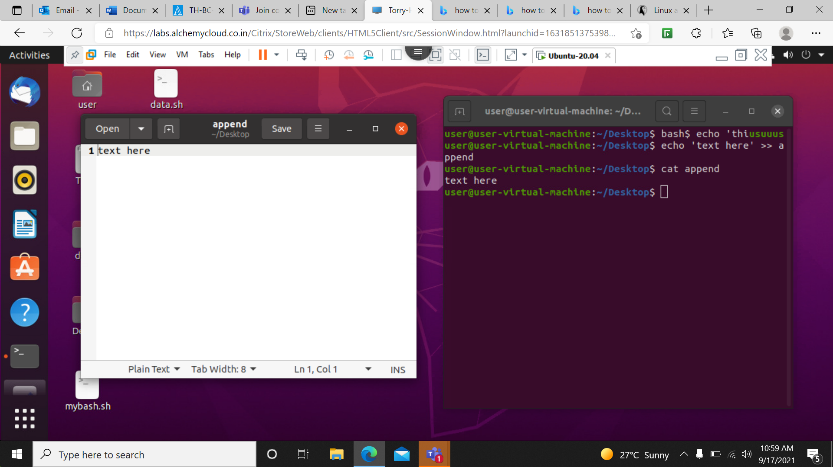

Program to find simple interest:

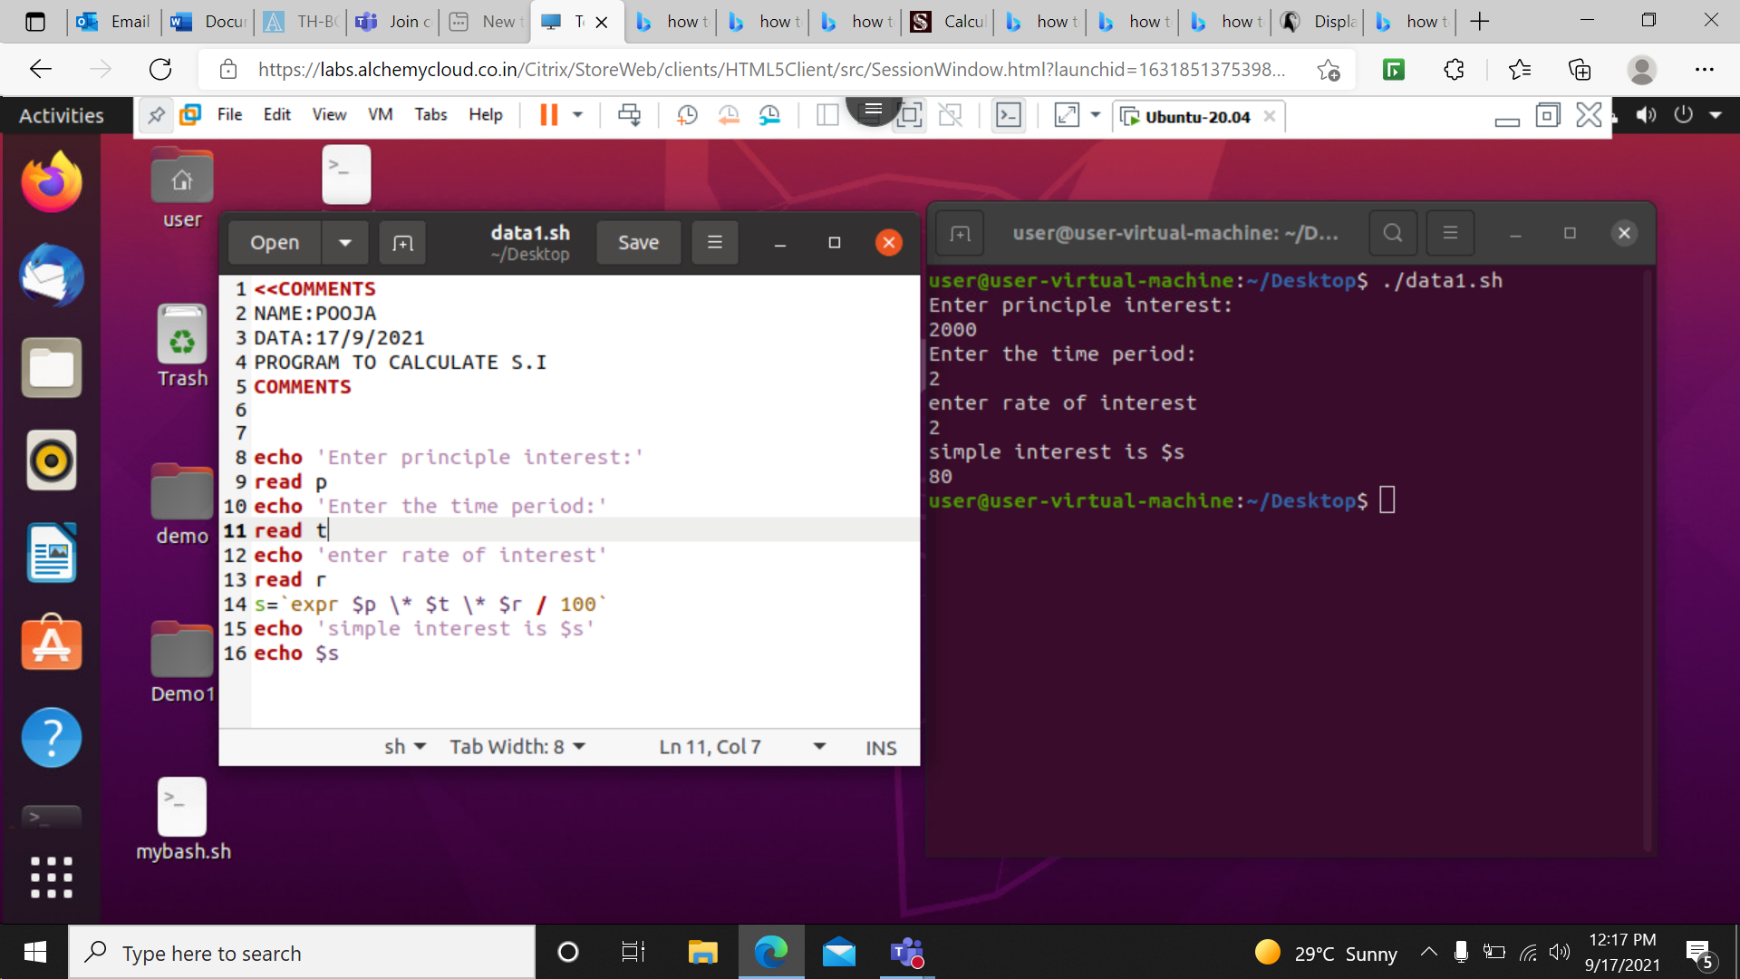

PROGRAM TO CALCULATE CIRCUMFERENCE OF CIRCLE

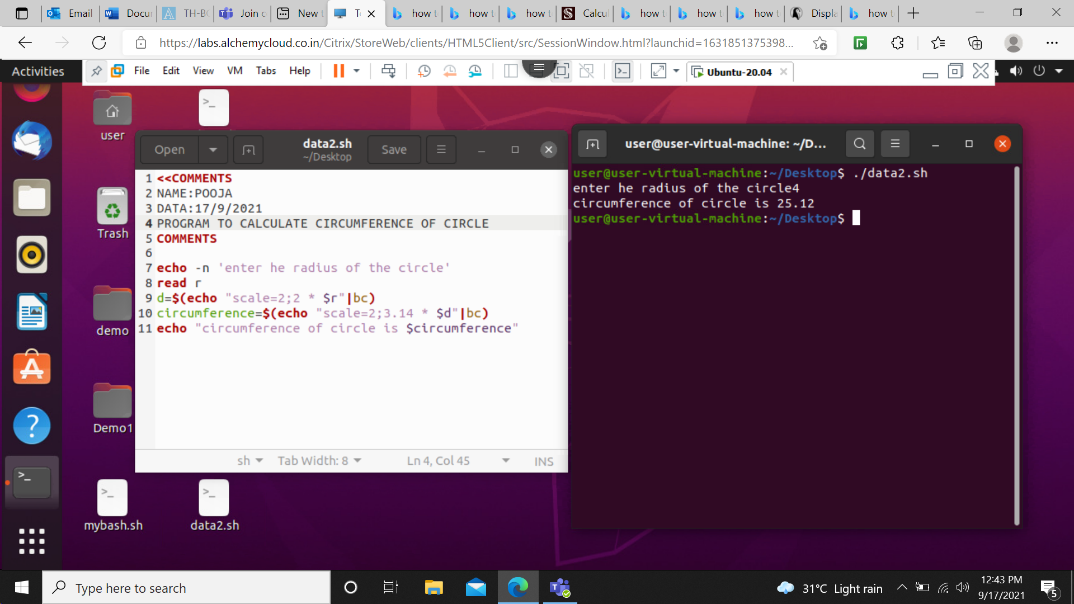

Program to calculate the diagonal of the triangle.

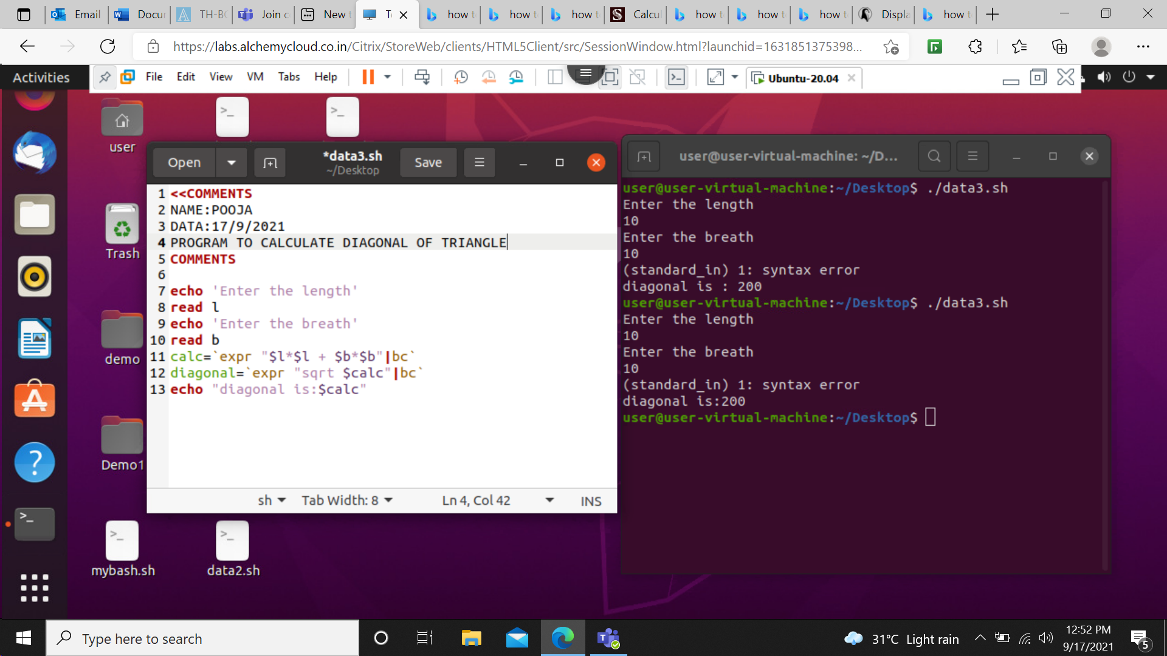

Program to print a table of a number given by user.

**echo "Enter a Number"**  
**read n**  
**i=1**  
  
**while [ $i -le 10 ]**  
**do**  
 **echo " $n x $i = $(( n * i ))"**  
 **i=$(( i + 1 ))**  
**done**

**Program to print a pattern like**

**\***

**\* \***

**\* * \***

**\* * * \***

**echo "Enter a Number"**  
**read rows**

|  |
| --- |
| **for**((i=1; i<=rows; i++))  **do**  **for**((j=1; j<=i; j++))  **do**  echo -n "* "  **done**  echo  **done** |

## 

**Program to print this pattern**

**1 2 3 4**

**5 6 7**

**8 9**

**10**

|  |
| --- |
| #Bash Shell Script to print inverted half pyramid using numbers  number=1  **for**((i=1; I<=n; i--))  **do**  **for**((j=1; j<=i; j++))  **do**  echo -n "$number "  number=$((number + 1))  **done**  number=1  echo  **done** |

## 